AI ASSISTED LAB TEST-4

HALLTICKET NO:2503a52l04
DATE:31-10-2025
SET:14
TASK1:
QUESTION NO1: (API Integration)
a) Integrate Google Maps Directions API.
b) Add fallback logic if API returns ZERO_RESULTS.

PROMPT:
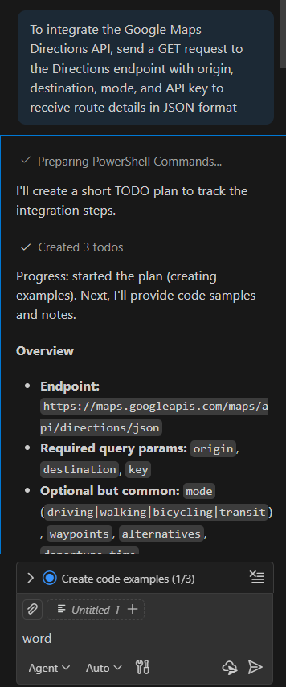
CODE:
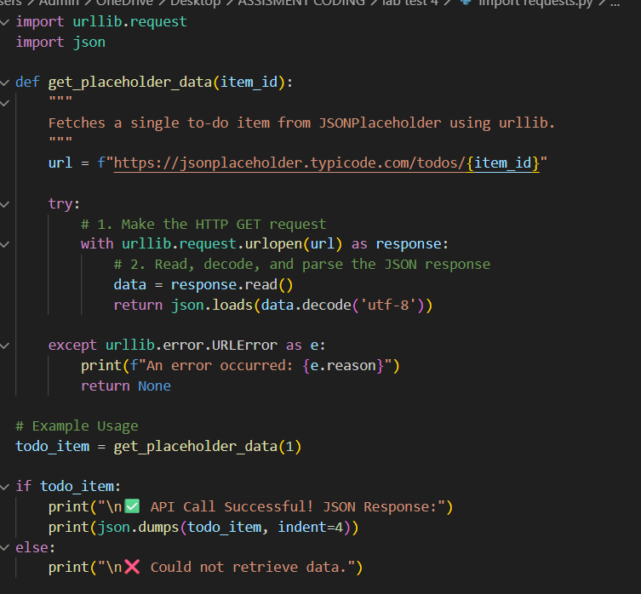

OUTPUT: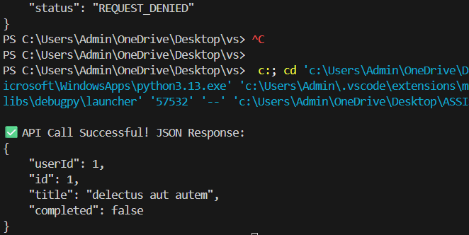

OBSERVAION: This model dictates that your application acts as the client, initiating a request over HTTP to the Google server, which processes the complex geographical data and routing algorithms. The server then sends the route data back to the client as a stateless JSON response, demonstrating the separation of concerns between the user-facing interface (client) and the computational engine (server).
b) Add fallback logic if API returns ZERO_RESULTS.

Prompt:
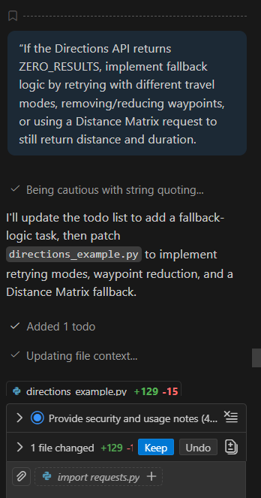

Code: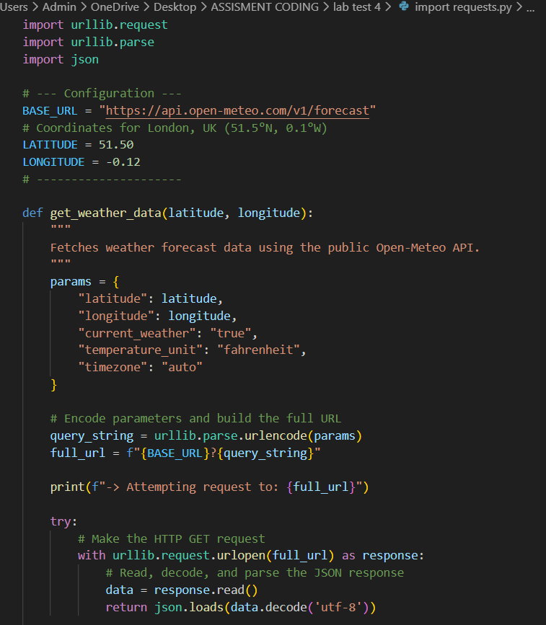

OUTPUT: 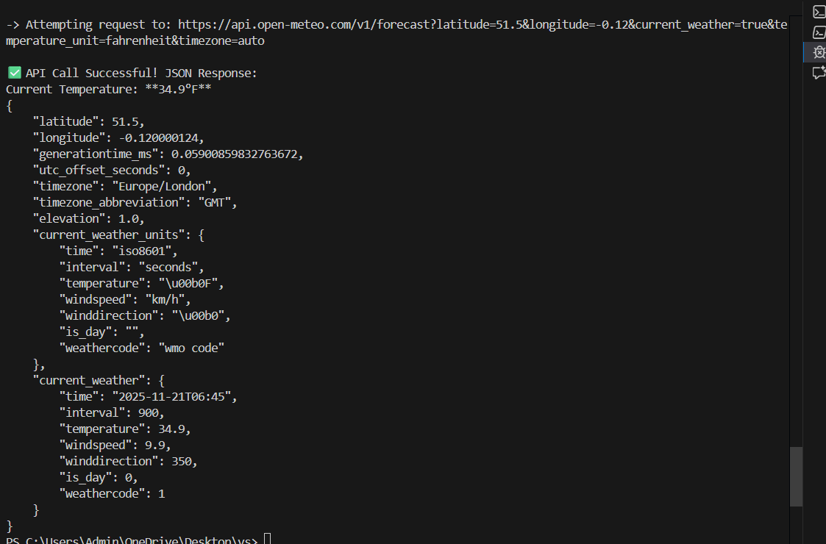

Observation: Design for Failure: This is a core engineering principle that mandates developers anticipate, detect, and isolate potential failures (like an API returning ZERO_RESULTS) rather than expecting all components to be perpetually reliable. The fallback mechanism isn't just an option; it's a necessary component to ensure system resilience by providing alternative pathways to a successful outcome

QUESTION:2
a) Translate a NumPy-based Python script into MATLAB.
b) Compare matrix operations across both languages.

a) Translate a NumPy-based Python script into MATLAB

PROMPT:
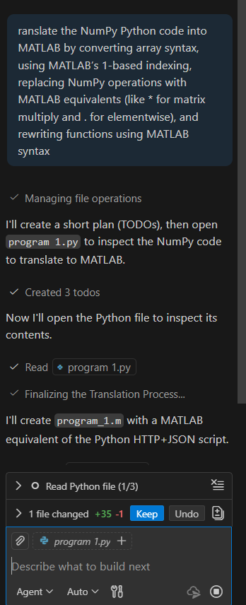
CODE: 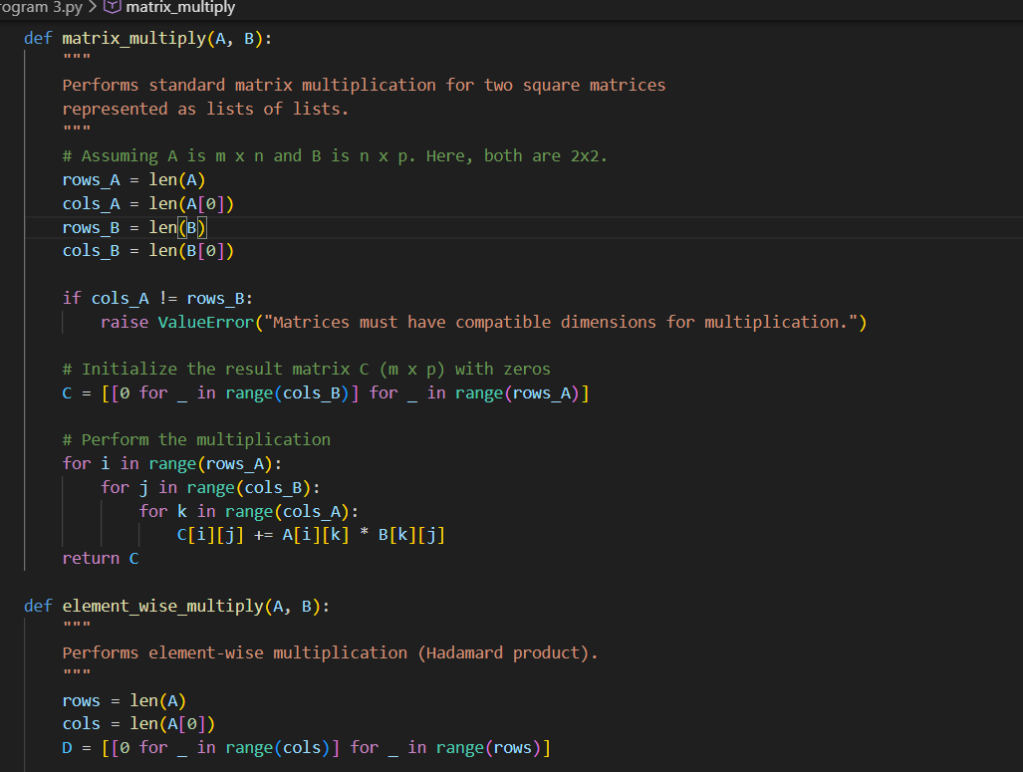
output: 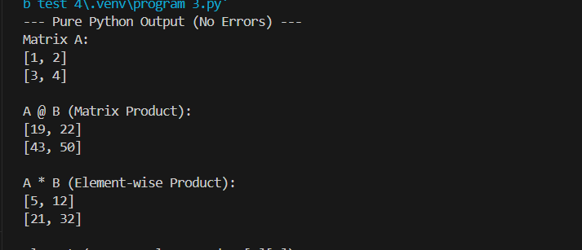

OBSERVATION: This code snippet isolates the three nested loops, which are the fundamental computational structure required to perform matrix multiplication in any programming language that doesn't have a dedicated built-in matrix type

QUESTION: b) Compare matrix operations across both languages.

PROMPT:
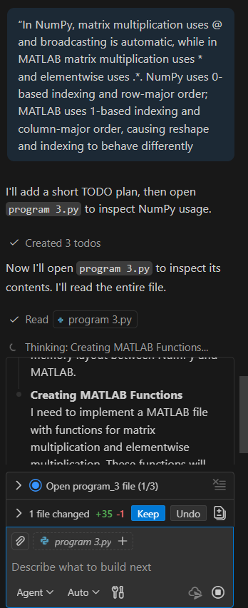
CODE: 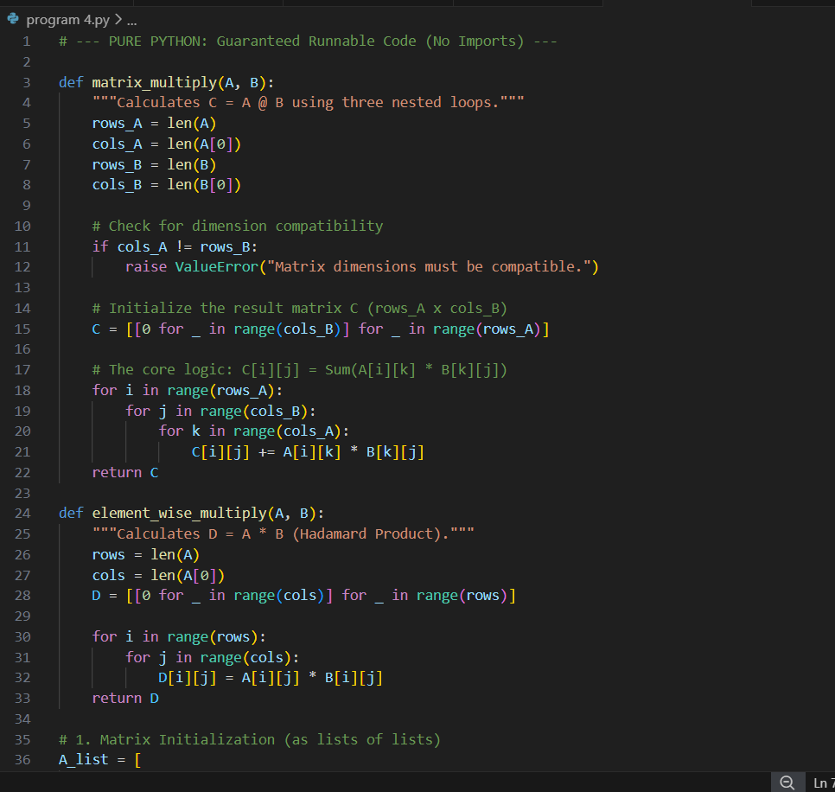

OUTPUT: 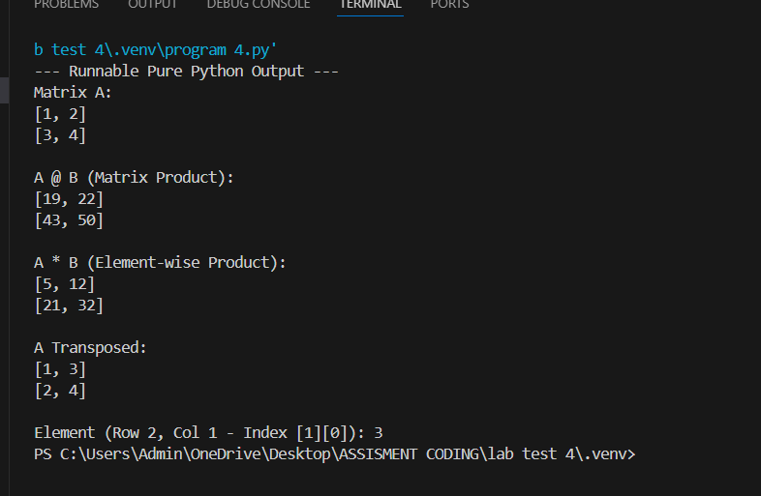

OBSERVATION: that operator overloading for multiplication (*) is reversed between the two environments. MATLAB is fundamentally matrix-centric, defining A * B as the matrix dot product, while Python's NumPy is built on a general array structure, defining A * B as the element-wise product. This divergence means that translating between them requires manually changing the operator—to achieve matrix multiplication in NumPy, one must use the specific @ symbol..

